**IN4640 Machine Vision**

**Assignment 1**

**Intensity Transformations and Neighborhood Filtering**

**215519C**

**N D G S Dissasekara**

1. Apply the following intensity transform to the image

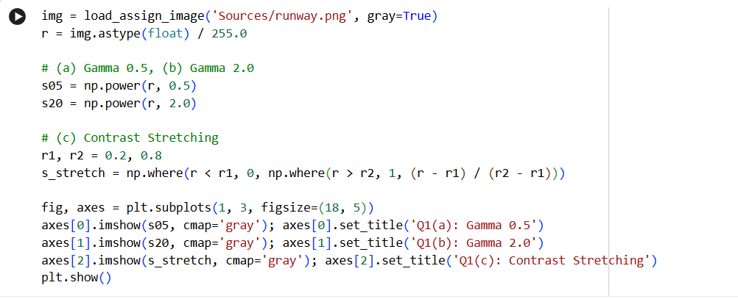

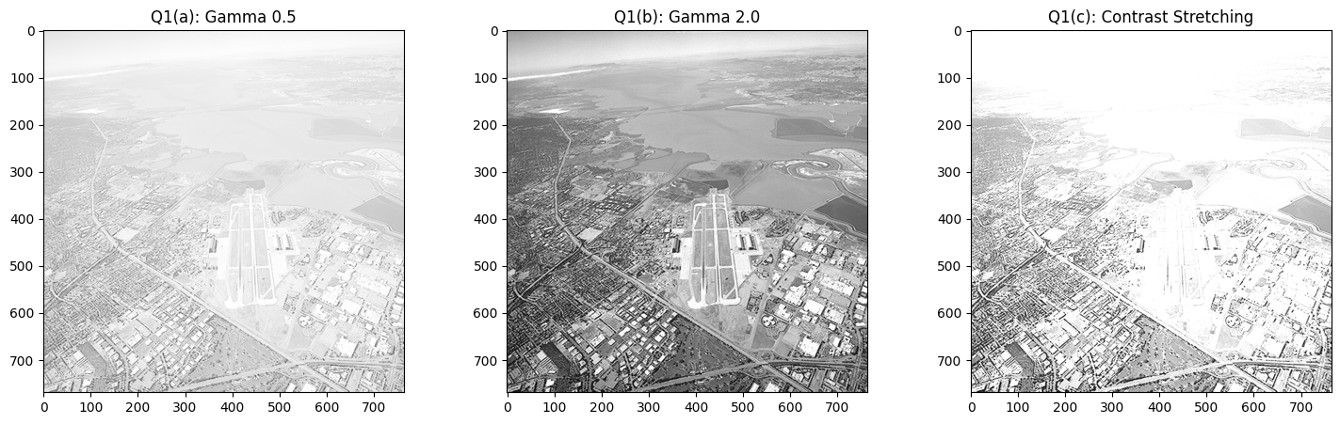

1. Apply gamma correction

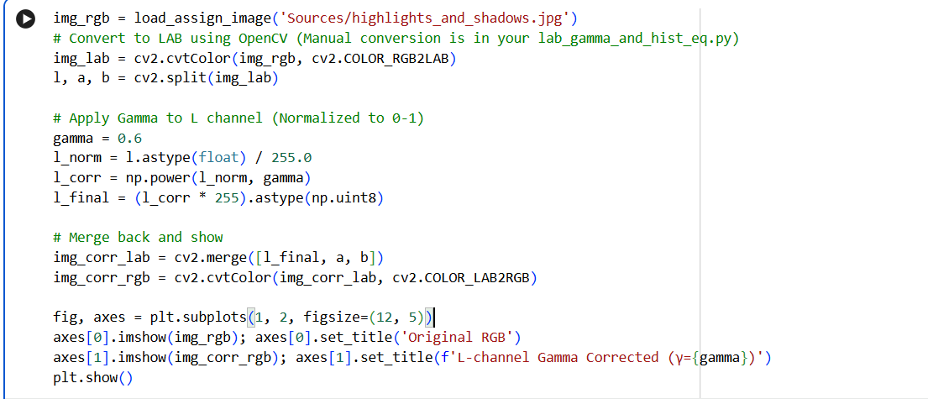

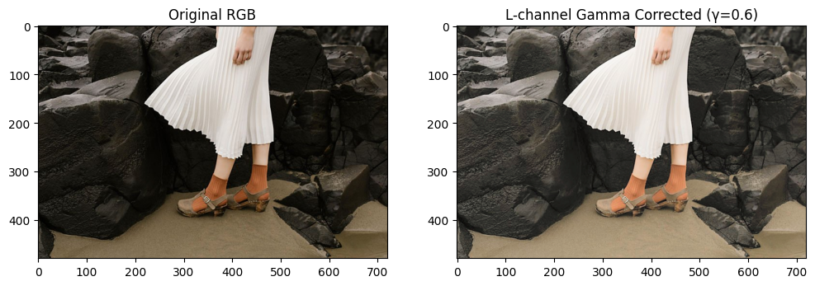

1. Write your own function to equalize the histogram of an image

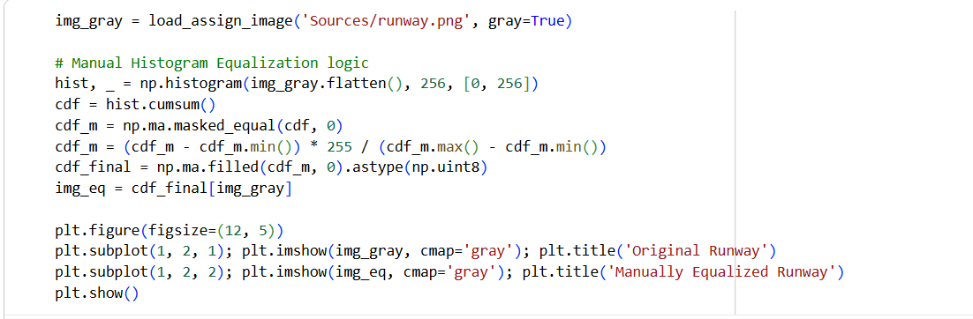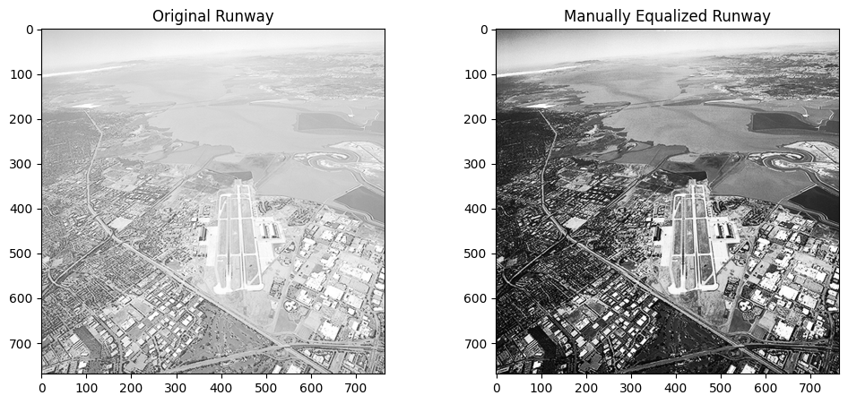

1. 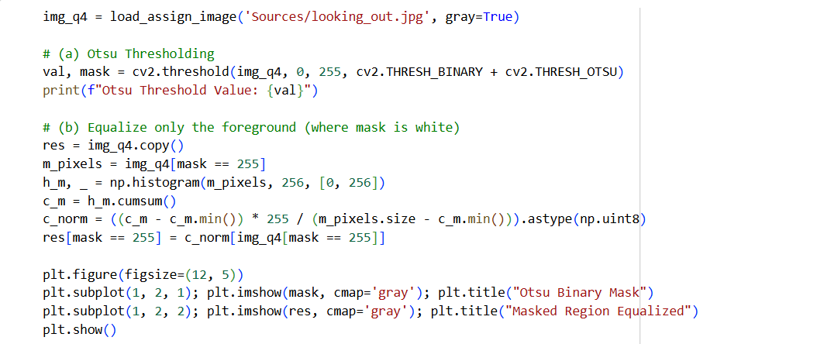Otsu thresholding
2. Otsu Threshold Value = 101.0
3. Features

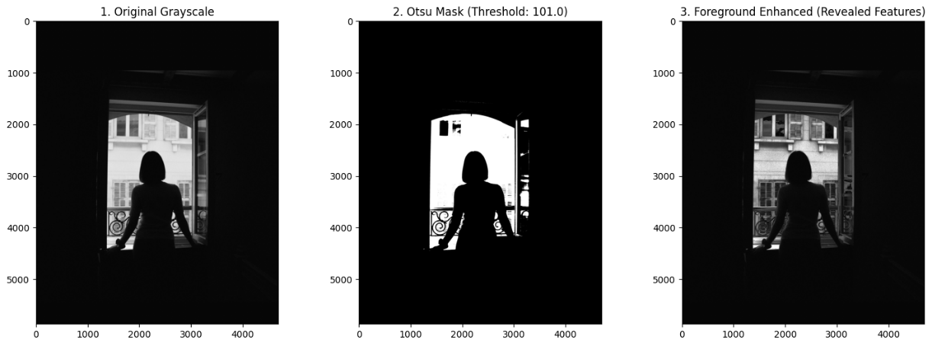

* Clothing Details -- Previously invisible fabric textures and folds (e.g., knit vs. smooth material) become visible.
* Hair Volume -- Highlights and individual strands appear, giving the hair realistic 3D depth.
* Room Interior -- Dark areas reveal wall textures, window frames, and surface details.
* Metalwork Details -- Fine features of railings or grills—joints, screws, and wear—become clear.
* Body Posture -- Shoulder curves, arm shape, and stance are now distinguishable.
* Floor & Furniture -- Hidden floor textures and unnoticed furniture elements emerge.

1. Gaussian filtering

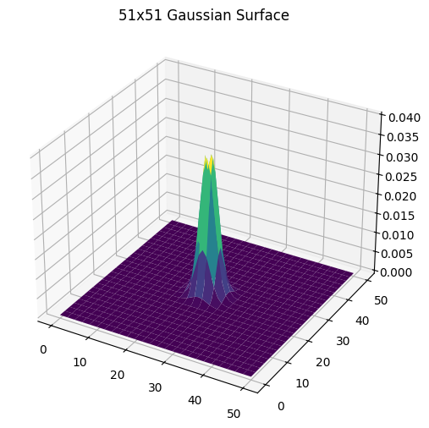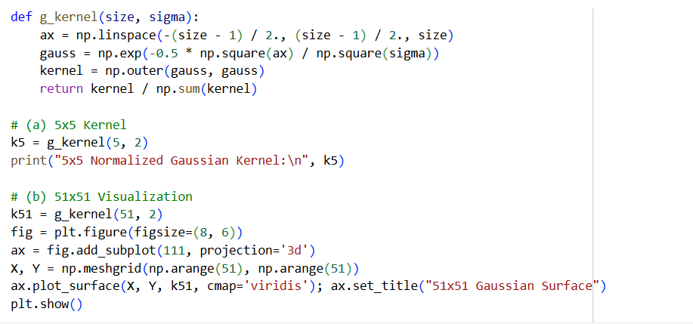

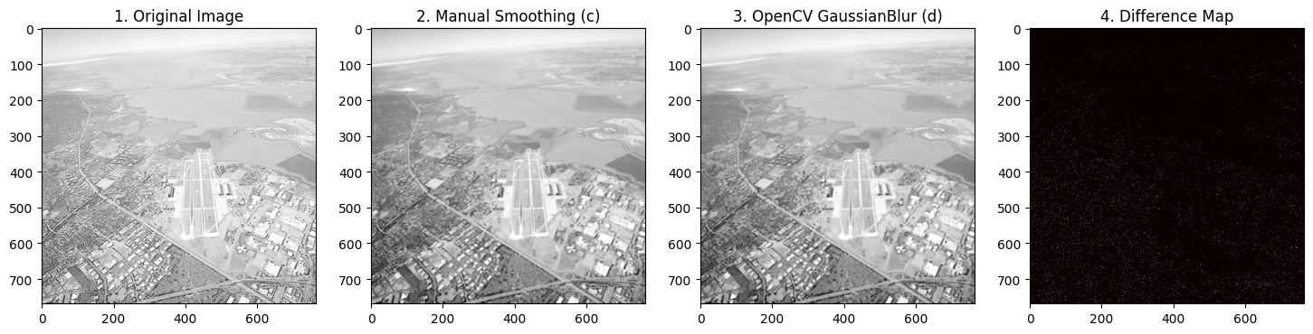

1. 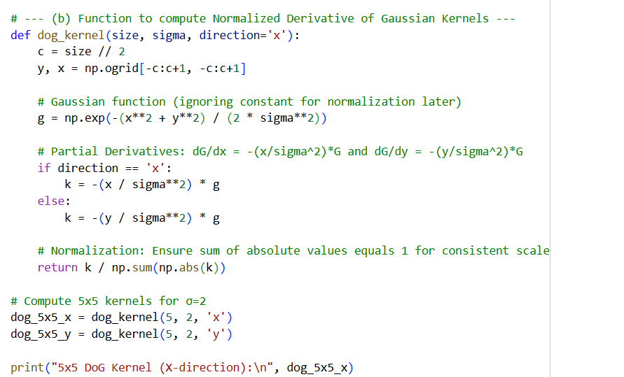Derivative of Gaussian
2. 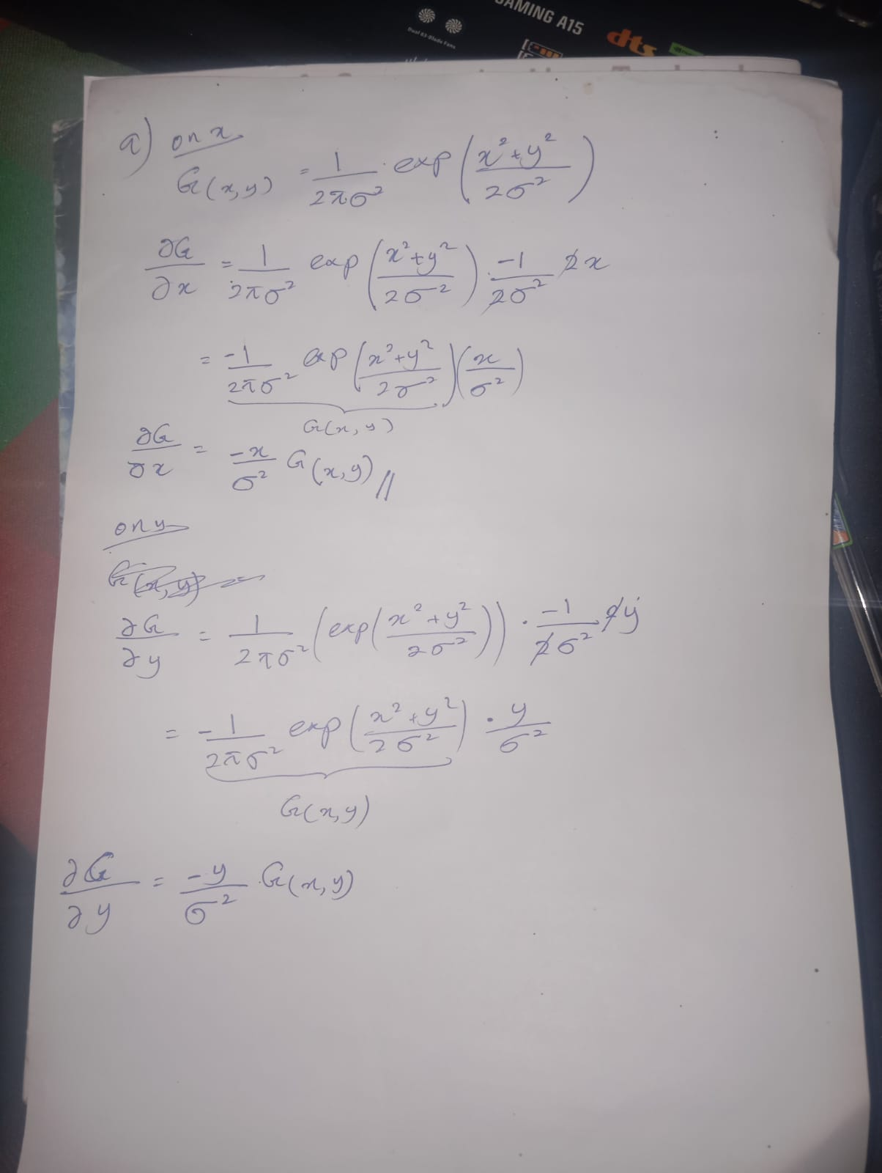
3. 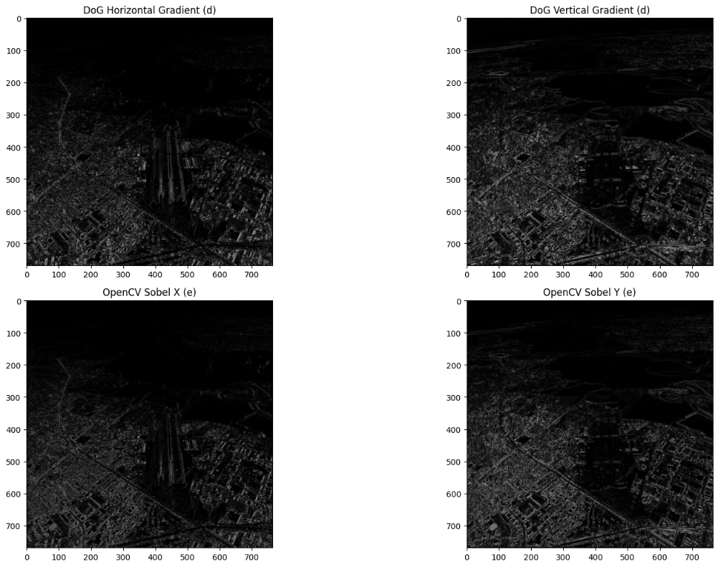
4. Zoom
   1. nearest neighbor

Scale: 5.00x | SSD (NN): 238.03

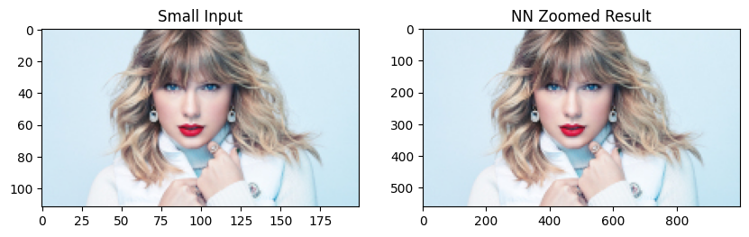

Scale: 20.00x | SSD (NN): 485.89

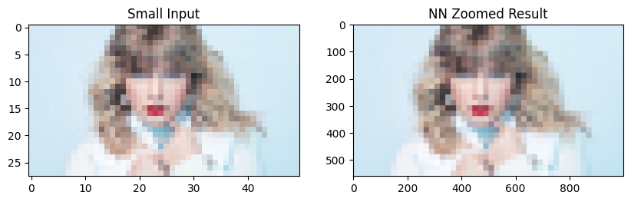

Scale: 4.00x | SSD (NN): 73.17

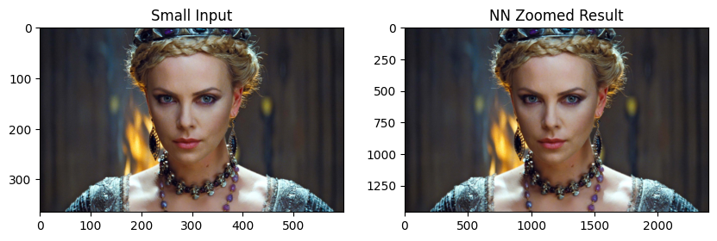

Scale: 4.00x | SSD (NN): 136.27

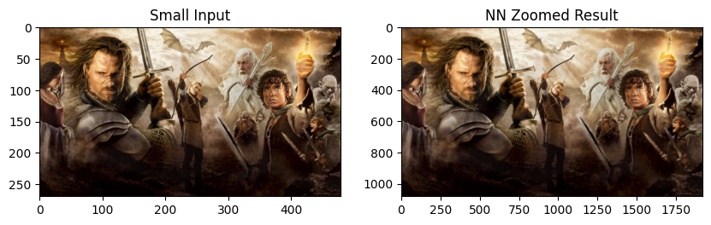

Scale: 4.00x | SSD (NN): 26.45

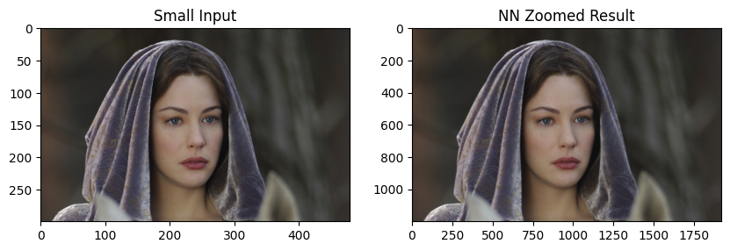

* 1. bilinear interpolation.

Scale: 5.00x | SSD (Bilinear): 285.14

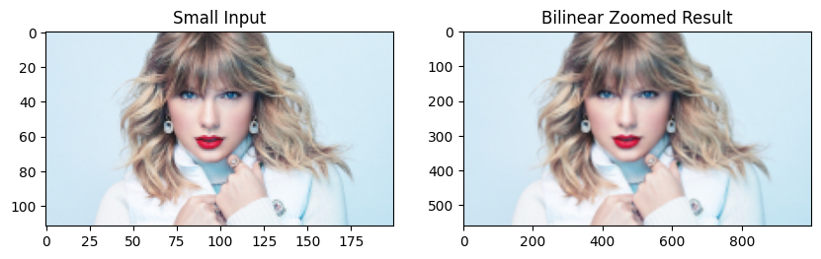

Scale: 20.00x | SSD (Bilinear): 654.60



Scale: 4.00x | SSD (Bilinear): 138.78

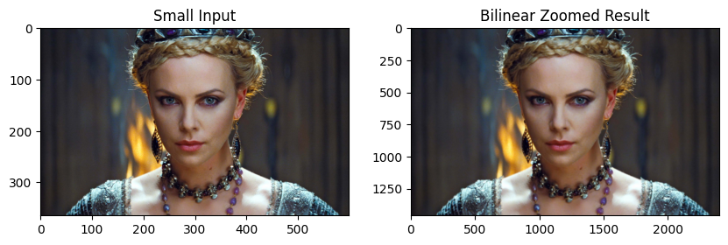

Scale: 4.00x | SSD (Bilinear): 200.25

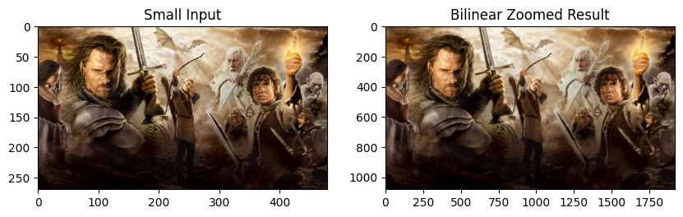

Scale: 4.00x | SSD (Bilinear): 48.96

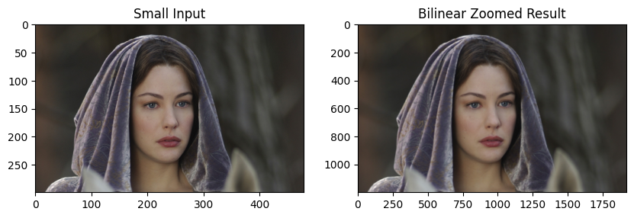

1. 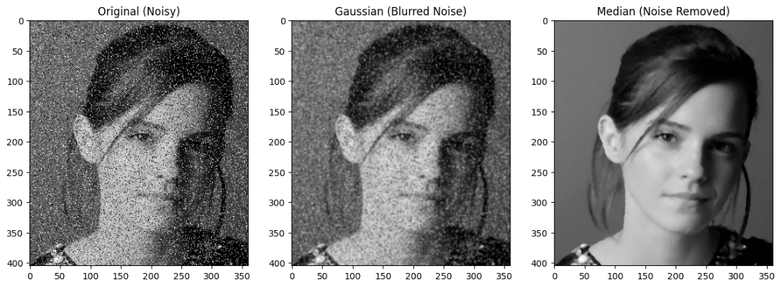Salt and paper noise
2. Sharpening

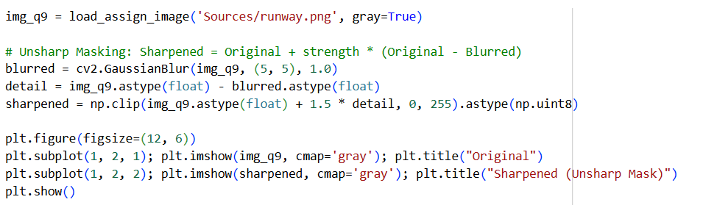

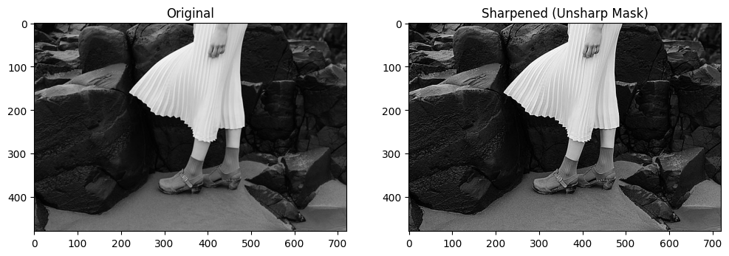

1. Bilateral filtering

